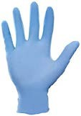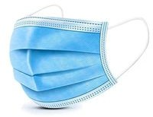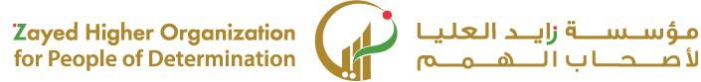

|  |  |  |  |  |  |  |  |
| --- | --- | --- | --- | --- | --- | --- | --- |
| **الاختبار اليومي** | | | | | | | |
| 14/1/2025 | **اﻟﺘﺎرﻳﺦ** | **اﻟﻔﺼﻞ اﻟﺜﺎﻟﺚ** | **اﻟﻔﺼﻞ اﻟﺪراﺳﻲ** | **2025** | **اﻟﺴﻨﺔ اﻟﺪراﺳﯿﺔ** | **ﻳُﺤﻀّﺮ ﻣﺨﺘﻠﻒ أﻧﻮاع ﻣﺸﺮوﺑﺎت اﻟﻘﮭﻮة** | **اﺳﻢ اﻟﻮﺣﺪة** |
| **ﻳﻠﺘﺰم ﺑﻠﺒﺲ اﻟﺰي اﻟﺨﺎص ﺑﺎﻟﻌﻤﻞ ﻳﻠﺒﺲ اﻟﻘﻔﺎزات اﻟﻮاﻗﯿﺔ**  **ﻳﺴﺘﺨﺪم اﻷدوات واﻷﺟﮭﺰة اﻟﺴﺎﺧﻨﺔ واﻟﺤﺎدّة ﺑﻄﺮﻳﻘﺔ ﺻﺤﯿﺤﺔ وآﻣﻨﺔ** | | | | | **ﻣﻌﯿﺎر اﻷداء** | **ﻳﻠﺘﺰم ﺑﻘﻮاﻋﺪ اﻷﻣﻦ واﻟﺴﻼﻣﺔ ﻓﻲ ﻣﻜﺎن اﻟﻌﻤﻞ** | **ﻣﺨﺮج اﻟﺘﻌﻠﻢ** |
| **اﻟﺪرس 1** | | | | | **رﻗﻢ اﻟﺪرس** | **ﻳﻠﺘﺰم ﺑﻠﺒﺲ اﻟﺰي اﻟﺨﺎص ﺑﺎﻟﻌﻤﻞ و ﻳﺴﺘﺨﺪم اﻷدوات**  **اﻟﺤﺎدة ﺑﻄﺮﻳﻘﺔ آﻣﻨﻪ** | **اﺳﻢ اﻟﺪرس** |
| 3 | | | | | **اﺳﻢ اﻟﻤﺠﻤﻮﻋﺔ** | ليلى محمد الحمادي | **اﺳﻢ اﻟﻄﺎﻟﺐ/ة** |
| **10** | | | | | | | **درﺟﺔ اﻻﺧﺘﺒﺎر** |
|  | | | | | | | **ﻧﺘﯿﺠﺔ اﻻﺧﺘﺒﺎر** |
|  | | | | | | | |
| **اﻟﺪرﺟﺎت** | **أسئلة اﻻﺧﺘﺒﺎر**  **صل ﻛﻞ أداة ﺑﻤﻜﺎﻧﮭﺎ اﻟﻤﻨﺎﺳﺐ** | | | | | | |



