

|  |  |  |  |  |  |  |  |
| --- | --- | --- | --- | --- | --- | --- | --- |
| **الاختبار اليومي** | | | | | | | |
|  | **اﻟﺘﺎرﻳﺦ** | **اﻟﻔﺼﻞ اﻟﺜﺎني** | **اﻟﻔﺼﻞ اﻟﺪراﺳﻲ** | **2025** | **اﻟﺴﻨﺔ اﻟﺪراﺳﯿﺔ** | **ﻳﻈٌﮭﺮ ﻣﻌﺮﻓﺔ وﻣﮭﺎرة ﻓﻲ أﺳﺎﺳﯿﺎت اﻟﺰراﻋﺔ واﻹﻧﺘﺎج**  **اﻟﺰراﻋﻲ** | **اﺳﻢ اﻟﻮﺣﺪة** |
| **ﻳﺤﺪد أﻧﻮاع اﻟﺰراﻋﺔ اﻟﺒﺴﯿﻄﺔ واﻟﺒﺪاﺋﯿﺔ واﺣﺘﯿﺎﺟﺎﺗﮭﺎ** | | | | | **ﻣﻌﯿﺎر اﻷداء** | **ﻳﻤﯿﺰ أﻧﻮاع اﻟﺰراﻋﺔ واﺣﺘﯿﺎﺟﺎﺗﮭﺎ** | **ﻣﺨﺮج اﻟﺘﻌﻠﻢ** |
| **اﻟﺪرس 3** | | | | | **رﻗﻢ اﻟﺪرس** | **ﺗﺤﺪﻳﺪ أﻧﻮاع اﻟﺰراﻋﺔ اﻟﺒﺪاﺋﯿﺔ واﺣﺘﯿﺎﺟﺎﺗﮭﺎ** | **اﺳﻢ اﻟﺪرس** |
| 1 | | | | | **اﺳﻢ اﻟﻤﺠﻤﻮﻋﺔ** | سعود | **اﺳﻢ اﻟﻄﺎﻟﺐ/ة** |
| **10** | | | | | | | **درﺟﺔ اﻻﺧﺘﺒﺎر** |
| **+** | | | | | | | **ﻧﺘﯿﺠﺔ اﻻﺧﺘﺒﺎر** |
|  | | | | | | | |
| **اﻟﺪرﺟﺎت** | **أسئلة اﻻﺧﺘﺒﺎر**  **رﺗﺐ ﺧﻄﻮات )ﻛﯿﻒ ﺗﺰرع ﻧﺒﺘﺔ؟(** | | | | | | |

**6**

**5**

**4**

**3**

**2**

**1**

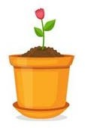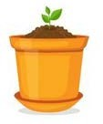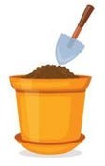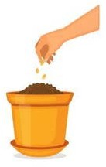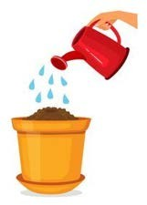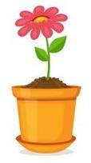

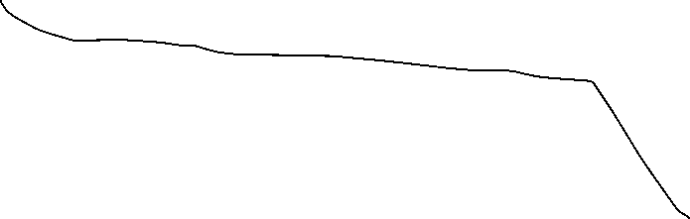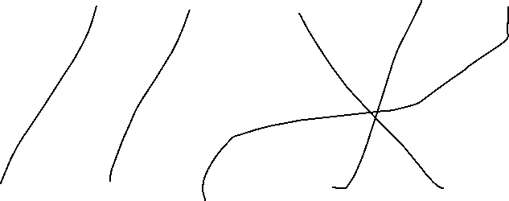



|  |  |  |  |  |  |  |  |
| --- | --- | --- | --- | --- | --- | --- | --- |
| **الاختبار اليومي** | | | | | | | |
|  | **اﻟﺘﺎرﻳﺦ** | **اﻟﻔﺼﻞ اﻟﺜﺎني** | **اﻟﻔﺼﻞ اﻟﺪراﺳﻲ** | **2025** | **اﻟﺴﻨﺔ اﻟﺪراﺳﯿﺔ** | **ﻳﻈٌﮭﺮ ﻣﻌﺮﻓﺔ وﻣﮭﺎرة ﻓﻲ أﺳﺎﺳﯿﺎت اﻟﺰراﻋﺔ واﻹﻧﺘﺎج**  **اﻟﺰراﻋﻲ** | **اﺳﻢ اﻟﻮﺣﺪة** |
| **ﻳﺤﺪد أﻧﻮاع اﻟﺰراﻋﺔ اﻟﺒﺴﯿﻄﺔ واﻟﺒﺪاﺋﯿﺔ واﺣﺘﯿﺎﺟﺎﺗﮭﺎ** | | | | | **ﻣﻌﯿﺎر اﻷداء** | **ﻳﻤﯿﺰ أﻧﻮاع اﻟﺰراﻋﺔ واﺣﺘﯿﺎﺟﺎﺗﮭﺎ** | **ﻣﺨﺮج اﻟﺘﻌﻠﻢ** |
| **اﻟﺪرس 3** | | | | | **رﻗﻢ اﻟﺪرس** | **ﺗﺤﺪﻳﺪ أﻧﻮاع اﻟﺰراﻋﺔ اﻟﺒﺪاﺋﯿﺔ واﺣﺘﯿﺎﺟﺎﺗﮭﺎ** | **اﺳﻢ اﻟﺪرس** |
| 1 | | | | | **اﺳﻢ اﻟﻤﺠﻤﻮﻋﺔ** | خميس | **اﺳﻢ اﻟﻄﺎﻟﺐ/ة** |
| **10** | | | | | | | **درﺟﺔ اﻻﺧﺘﺒﺎر** |
| **M** | | | | | | | **ﻧﺘﯿﺠﺔ اﻻﺧﺘﺒﺎر** |
|  | | | | | | | |
| **اﻟﺪرﺟﺎت** | **أسئلة اﻻﺧﺘﺒﺎر**  **رﺗﺐ ﺧﻄﻮات )ﻛﯿﻒ ﺗﺰرع ﻧﺒﺘﺔ؟(** | | | | | | |

**6**

**5**

**4**

**3**

**2**

**1**

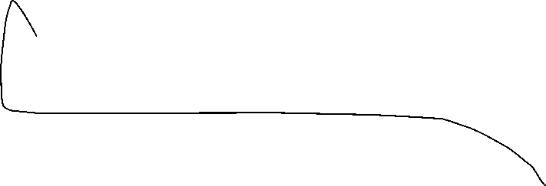



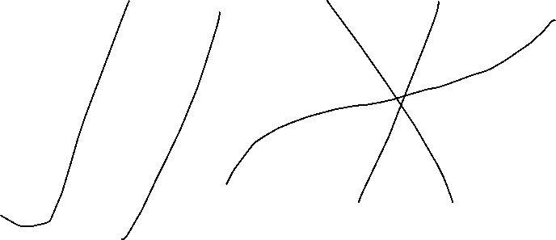



|  |  |  |  |  |  |  |  |
| --- | --- | --- | --- | --- | --- | --- | --- |
| **الاختبار اليومي** | | | | | | | |
|  | **اﻟﺘﺎرﻳﺦ** | **اﻟﻔﺼﻞ اﻟﺜﺎني** | **اﻟﻔﺼﻞ اﻟﺪراﺳﻲ** | **2025** | **اﻟﺴﻨﺔ اﻟﺪراﺳﯿﺔ** | **ﻳﻈٌﮭﺮ ﻣﻌﺮﻓﺔ وﻣﮭﺎرة ﻓﻲ أﺳﺎﺳﯿﺎت اﻟﺰراﻋﺔ واﻹﻧﺘﺎج**  **اﻟﺰراﻋﻲ** | **اﺳﻢ اﻟﻮﺣﺪة** |
| **ﻳﺤﺪد أﻧﻮاع اﻟﺰراﻋﺔ اﻟﺒﺴﯿﻄﺔ واﻟﺒﺪاﺋﯿﺔ واﺣﺘﯿﺎﺟﺎﺗﮭﺎ** | | | | | **ﻣﻌﯿﺎر اﻷداء** | **ﻳﻤﯿﺰ أﻧﻮاع اﻟﺰراﻋﺔ واﺣﺘﯿﺎﺟﺎﺗﮭﺎ** | **ﻣﺨﺮج اﻟﺘﻌﻠﻢ** |
| **اﻟﺪرس 3** | | | | | **رﻗﻢ اﻟﺪرس** | **ﺗﺤﺪﻳﺪ أﻧﻮاع اﻟﺰراﻋﺔ اﻟﺒﺪاﺋﯿﺔ واﺣﺘﯿﺎﺟﺎﺗﮭﺎ** | **اﺳﻢ اﻟﺪرس** |
| 1 | | | | | **اﺳﻢ اﻟﻤﺠﻤﻮﻋﺔ** | أديب | **اﺳﻢ اﻟﻄﺎﻟﺐ/ة** |
| **10** | | | | | | | **درﺟﺔ اﻻﺧﺘﺒﺎر** |
| **+** | | | | | | | **ﻧﺘﯿﺠﺔ اﻻﺧﺘﺒﺎر** |
|  | | | | | | | |
| **اﻟﺪرﺟﺎت** | **أسئلة اﻻﺧﺘﺒﺎر**  **رﺗﺐ ﺧﻄﻮات )ﻛﯿﻒ ﺗﺰرع ﻧﺒﺘﺔ؟(** | | | | | | |

**6**

**5**

**4**

**3**

**2**

**1**



