

|  |  |  |  |  |  |  |  |
| --- | --- | --- | --- | --- | --- | --- | --- |
| **الاختبار اليومي** | | | | | | | |
|  | **اﻟﺘﺎرﻳﺦ** | **اﻟﻔﺼﻞ اﻟﺜﺎني** | **اﻟﻔﺼﻞ اﻟﺪراﺳﻲ** | **2025** | **اﻟﺴﻨﺔ اﻟﺪراﺳﯿﺔ** | **ﻳٌﻈﮭﺮ ﻣﻌﺮﻓﺔ وﻣﮭﺎرة ﻓﻲ أﺳﺎﺳﯿﺎت اﻟﻄﮭﻲ** | **اﺳﻢ اﻟﻮﺣﺪة** |
| **ﻳﺤﺪد أﻣﺎﻛﻦ اﻟﺤﺼﻮل ﻋﻠﻰ اﻟﺴﻠﻊ اﻟﻐﺬاﺋﯿﺔ اﻟﻤﺘﻨﻮﻋﺔ ﻳﺬﻛﺮ ﻓﻮاﺋﺪ اﺳﺘﺨﺪام اﻟﺴﻠﻊ اﻟﻐﺬاﺋﯿﺔ**  **ﻳﺤﺪد ﻛﻤﯿﺔ اﻟﻤﻮاد اﻟﻐﺬاﺋﯿﺔ ﻹﻋﺪاد اﻟﻄﻌﺎم** | | | | | **ﻣﻌﯿﺎر اﻷداء** | **ﻳﺼﻒ أﻧﻮاع اﻟﻤﻮاد اﻟﻐﺬاﺋﯿﺔ** | **ﻣﺨﺮج اﻟﺘﻌﻠﻢ** |
| **اﻟﺪرس 4** | | | | | **رﻗﻢ اﻟﺪرس** | **اﻟﺤﺼﻮل ﻋﻠﻰ اﻟﺴﻠﻊ اﻟﻐﺬاﺋﯿﺔ وﻛﻤﯿﺘﮭﺎ** | **اﺳﻢ اﻟﺪرس** |
| 1 | | | | | **اﺳﻢ اﻟﻤﺠﻤﻮﻋﺔ** | خميس | **اﺳﻢ اﻟﻄﺎﻟﺐ/ة** |
| **10** | | | | | | | **درﺟﺔ اﻻﺧﺘﺒﺎر** |
| **FP** | | | | | | | **ﻧﺘﯿﺠﺔ اﻻﺧﺘﺒﺎر** |
|  | | | | | | | |
| **اﻟﺪرﺟﺎت**  **10**  **-------** | **أسئلة الاختبار**  **اﻟﺴﺆال اﻷول ﺻﻨﻒ اﻟﺴﻠﻊ اﻟﺘﺎﻟﯿﺔ ﺣﺴﺐ اﻟﻤﻜﺎن اﻟﺬي ﻳﻤﻜﻦ ﺷﺮاؤھﺎ ﻣﻨﻪ** | | | | | | |

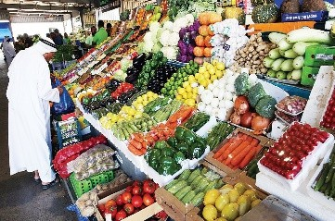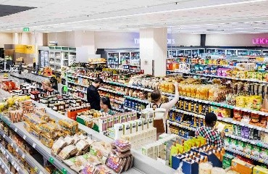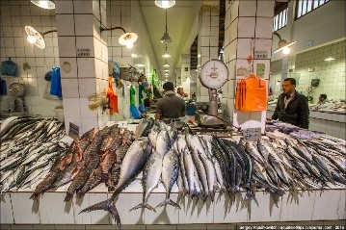

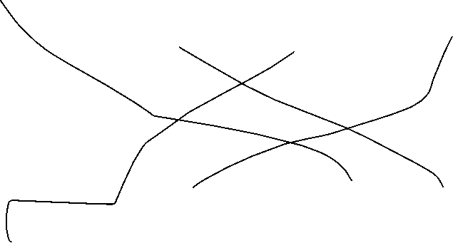

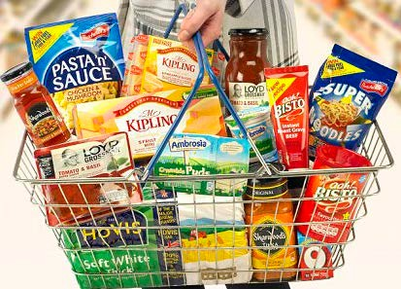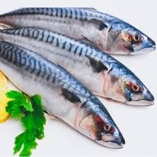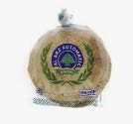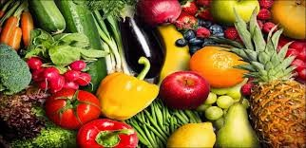

اﻋﺪاد وﺗﻘﺪ�ﻢ: أ / ﺣﻤﺎﻣﻪ اﻟﻤﻨﺼﻮري

ﻣﺮﻛﺰ ﻣﺪﻳﻨﺔ زا�ﺪ



|  |  |  |  |  |  |  |  |
| --- | --- | --- | --- | --- | --- | --- | --- |
| **الاختبار اليومي** | | | | | | | |
|  | **اﻟﺘﺎرﻳﺦ** | **اﻟﻔﺼﻞ اﻟﺜﺎني** | **اﻟﻔﺼﻞ اﻟﺪراﺳﻲ** | **2025** | **اﻟﺴﻨﺔ اﻟﺪراﺳﯿﺔ** | **ﻳٌﻈﮭﺮ ﻣﻌﺮﻓﺔ وﻣﮭﺎرة ﻓﻲ أﺳﺎﺳﯿﺎت اﻟﻄﮭﻲ** | **اﺳﻢ اﻟﻮﺣﺪة** |
| **ﻳﺤﺪد أﻣﺎﻛﻦ اﻟﺤﺼﻮل ﻋﻠﻰ اﻟﺴﻠﻊ اﻟﻐﺬاﺋﯿﺔ اﻟﻤﺘﻨﻮﻋﺔ ﻳﺬﻛﺮ ﻓﻮاﺋﺪ اﺳﺘﺨﺪام اﻟﺴﻠﻊ اﻟﻐﺬاﺋﯿﺔ**  **ﻳﺤﺪد ﻛﻤﯿﺔ اﻟﻤﻮاد اﻟﻐﺬاﺋﯿﺔ ﻹﻋﺪاد اﻟﻄﻌﺎم** | | | | | **ﻣﻌﯿﺎر اﻷداء** | **ﻳﺼﻒ أﻧﻮاع اﻟﻤﻮاد اﻟﻐﺬاﺋﯿﺔ** | **ﻣﺨﺮج اﻟﺘﻌﻠﻢ** |
| **اﻟﺪرس 4** | | | | | **رﻗﻢ اﻟﺪرس** | **اﻟﺤﺼﻮل ﻋﻠﻰ اﻟﺴﻠﻊ اﻟﻐﺬاﺋﯿﺔ وﻛﻤﯿﺘﮭﺎ** | **اﺳﻢ اﻟﺪرس** |
| 1 | | | | | **اﺳﻢ اﻟﻤﺠﻤﻮﻋﺔ** | بشير | **اﺳﻢ اﻟﻄﺎﻟﺐ/ة** |
| **10** | | | | | | | **درﺟﺔ اﻻﺧﺘﺒﺎر** |
| **v** | | | | | | | **ﻧﺘﯿﺠﺔ اﻻﺧﺘﺒﺎر** |
|  | | | | | | | |
| **اﻟﺪرﺟﺎت**  **10**  **-------** | **أسئلة الاختبار**  **اﻟﺴﺆال اﻷول ﺻﻨﻒ اﻟﺴﻠﻊ اﻟﺘﺎﻟﯿﺔ ﺣﺴﺐ اﻟﻤﻜﺎن اﻟﺬي ﻳﻤﻜﻦ ﺷﺮاؤھﺎ ﻣﻨﻪ** | | | | | | |



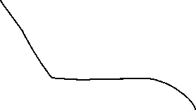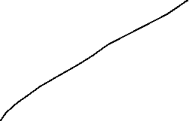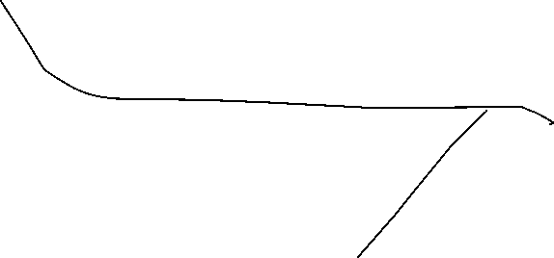

اﻋﺪاد وﺗﻘﺪ�ﻢ: أ / ﺣﻤﺎﻣﻪ اﻟﻤﻨﺼﻮري

ﻣﺮﻛﺰ ﻣﺪﻳﻨﺔ زا�ﺪ



|  |  |  |  |  |  |  |  |
| --- | --- | --- | --- | --- | --- | --- | --- |
| **الاختبار اليومي** | | | | | | | |
|  | **اﻟﺘﺎرﻳﺦ** | **اﻟﻔﺼﻞ اﻟﺜﺎني** | **اﻟﻔﺼﻞ اﻟﺪراﺳﻲ** | **2025** | **اﻟﺴﻨﺔ اﻟﺪراﺳﯿﺔ** | **ﻳٌﻈﮭﺮ ﻣﻌﺮﻓﺔ وﻣﮭﺎرة ﻓﻲ أﺳﺎﺳﯿﺎت اﻟﻄﮭﻲ** | **اﺳﻢ اﻟﻮﺣﺪة** |
| **ﻳﺤﺪد أﻣﺎﻛﻦ اﻟﺤﺼﻮل ﻋﻠﻰ اﻟﺴﻠﻊ اﻟﻐﺬاﺋﯿﺔ اﻟﻤﺘﻨﻮﻋﺔ ﻳﺬﻛﺮ ﻓﻮاﺋﺪ اﺳﺘﺨﺪام اﻟﺴﻠﻊ اﻟﻐﺬاﺋﯿﺔ**  **ﻳﺤﺪد ﻛﻤﯿﺔ اﻟﻤﻮاد اﻟﻐﺬاﺋﯿﺔ ﻹﻋﺪاد اﻟﻄﻌﺎم** | | | | | **ﻣﻌﯿﺎر اﻷداء** | **ﻳﺼﻒ أﻧﻮاع اﻟﻤﻮاد اﻟﻐﺬاﺋﯿﺔ** | **ﻣﺨﺮج اﻟﺘﻌﻠﻢ** |
| **اﻟﺪرس 4** | | | | | **رﻗﻢ اﻟﺪرس** | **اﻟﺤﺼﻮل ﻋﻠﻰ اﻟﺴﻠﻊ اﻟﻐﺬاﺋﯿﺔ وﻛﻤﯿﺘﮭﺎ** | **اﺳﻢ اﻟﺪرس** |
| 1 | | | | | **اﺳﻢ اﻟﻤﺠﻤﻮﻋﺔ** | أديب | **اﺳﻢ اﻟﻄﺎﻟﺐ/ة** |
| **10** | | | | | | | **درﺟﺔ اﻻﺧﺘﺒﺎر** |
| **V** | | | | | | | **ﻧﺘﯿﺠﺔ اﻻﺧﺘﺒﺎر** |
|  | | | | | | | |
| **اﻟﺪرﺟﺎت**  **10**  **-------** | **أسئلة الاختبار**  **اﻟﺴﺆال اﻷول ﺻﻨﻒ اﻟﺴﻠﻊ اﻟﺘﺎﻟﯿﺔ ﺣﺴﺐ اﻟﻤﻜﺎن اﻟﺬي ﻳﻤﻜﻦ ﺷﺮاؤھﺎ ﻣﻨﻪ** | | | | | | |





اﻋﺪاد وﺗﻘﺪ�ﻢ: أ / ﺣﻤﺎﻣﻪ اﻟﻤﻨﺼﻮري

ﻣﺮﻛﺰ ﻣﺪﻳﻨﺔ زا�ﺪ



|  |  |  |  |  |  |  |  |
| --- | --- | --- | --- | --- | --- | --- | --- |
| **الاختبار اليومي** | | | | | | | |
|  | **اﻟﺘﺎرﻳﺦ** | **اﻟﻔﺼﻞ اﻟﺜﺎني** | **اﻟﻔﺼﻞ اﻟﺪراﺳﻲ** | **2025** | **اﻟﺴﻨﺔ اﻟﺪراﺳﯿﺔ** | **ﻳٌﻈﮭﺮ ﻣﻌﺮﻓﺔ وﻣﮭﺎرة ﻓﻲ أﺳﺎﺳﯿﺎت اﻟﻄﮭﻲ** | **اﺳﻢ اﻟﻮﺣﺪة** |
| **ﻳﺤﺪد أﻣﺎﻛﻦ اﻟﺤﺼﻮل ﻋﻠﻰ اﻟﺴﻠﻊ اﻟﻐﺬاﺋﯿﺔ اﻟﻤﺘﻨﻮﻋﺔ ﻳﺬﻛﺮ ﻓﻮاﺋﺪ اﺳﺘﺨﺪام اﻟﺴﻠﻊ اﻟﻐﺬاﺋﯿﺔ**  **ﻳﺤﺪد ﻛﻤﯿﺔ اﻟﻤﻮاد اﻟﻐﺬاﺋﯿﺔ ﻹﻋﺪاد اﻟﻄﻌﺎم** | | | | | **ﻣﻌﯿﺎر اﻷداء** | **ﻳﺼﻒ أﻧﻮاع اﻟﻤﻮاد اﻟﻐﺬاﺋﯿﺔ** | **ﻣﺨﺮج اﻟﺘﻌﻠﻢ** |
| **اﻟﺪرس 4** | | | | | **رﻗﻢ اﻟﺪرس** | **اﻟﺤﺼﻮل ﻋﻠﻰ اﻟﺴﻠﻊ اﻟﻐﺬاﺋﯿﺔ وﻛﻤﯿﺘﮭﺎ** | **اﺳﻢ اﻟﺪرس** |
| 1 | | | | | **اﺳﻢ اﻟﻤﺠﻤﻮﻋﺔ** | سعود | **اﺳﻢ اﻟﻄﺎﻟﺐ/ة** |
| **10** | | | | | | | **درﺟﺔ اﻻﺧﺘﺒﺎر** |
| **G** | | | | | | | **ﻧﺘﯿﺠﺔ اﻻﺧﺘﺒﺎر** |
|  | | | | | | | |
| **اﻟﺪرﺟﺎت**  **10**  **-------** | **أسئلة الاختبار**  **اﻟﺴﺆال اﻷول ﺻﻨﻒ اﻟﺴﻠﻊ اﻟﺘﺎﻟﯿﺔ ﺣﺴﺐ اﻟﻤﻜﺎن اﻟﺬي ﻳﻤﻜﻦ ﺷﺮاؤھﺎ ﻣﻨﻪ** | | | | | | |



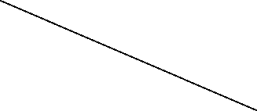

اﻋﺪاد وﺗﻘﺪ�ﻢ: أ / ﺣﻤﺎﻣﻪ اﻟﻤﻨﺼﻮري

ﻣﺮﻛﺰ ﻣﺪﻳﻨﺔ زا�ﺪ