

|  |  |  |  |  |  |  |  |
| --- | --- | --- | --- | --- | --- | --- | --- |
| **اﻻﺧﺘبﺎر اﻟﻴﻮ ي�** | | | | | | | |
|  | **اﻟﺘﺎرﻳﺦ** | **اﻟﻔﺼﻞ اﻟﺜﺎﻟﺚ** | **اﻟﻔﺼﻞ اﻟﺪراﺳﻲ** | **2025** | **اﻟﺴﻨﺔ اﻟﺪراﺳﯿﺔ** | **ﻳٌﻈﮭﺮ ﻣﻌﺮﻓﺔ وﻣﮭﺎرة ﻓﻲ أﺳﺎﺳﯿﺎت اﻟﻄﮭﻲ** | **اﺳﻢ اﻟﻮﺣﺪة** |
| **ﻳﺤﺪد أﻣﺎﻛﻦ اﻟﺤﺼﻮل ﻋﻠﻰ اﻟﺴﻠﻊ اﻟﻐﺬاﺋﯿﺔ اﻟﻤﺘﻨﻮﻋﺔ**  **ﻳﺬﻛﺮ ﻓﻮاﺋﺪ اﺳﺘﺨﺪام اﻟﺴﻠﻊ اﻟﻐﺬاﺋﯿﺔ ﻳﺤﺪد ﻛﻤﯿﺔ اﻟﻤﻮاد اﻟﻐﺬاﺋﯿﺔ ﻹﻋﺪاد اﻟﻄﻌﺎم** | | | | | **ﻣﻌﯿﺎر اﻷداء** | **ﻳﺼﻒ أﻧﻮاع اﻟﻤﻮاد اﻟﻐﺬاﺋﯿﺔ** | **ﻣﺨﺮج اﻟﺘﻌﻠﻢ** |
| **اﻟﺪرس 4** | | | | | **رﻗﻢ اﻟﺪرس** | **اﻟﺤﺼﻮل ﻋﻠﻰ اﻟﺴﻠﻊ اﻟﻐﺬاﺋﯿﺔ وﻛﻤﯿﺘﮭﺎ** | **اﺳﻢ اﻟﺪرس** |
| 2 | | | | | **اﺳﻢ اﻟﻤﺠﻤﻮﻋﺔ** | ربيع- محمد سالم – محمد جاسم -يوسف | **اﺳﻢ اﻟﻄﺎﻟﺐ/ة** |
| **10** | | | | | | | **درﺟﺔ اﻻﺧﺘﺒﺎر** |
| **.........** | | | | | | | **ﻧﺘﯿﺠﺔ اﻻﺧﺘﺒﺎر** |

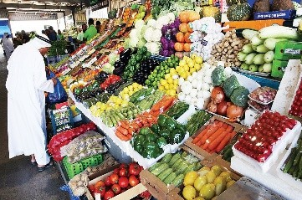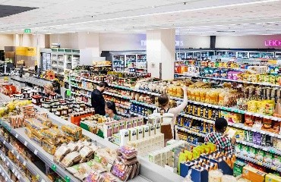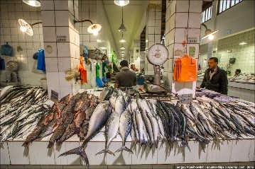

**اﺳﺎﻟﺔ اﻻﺧﺘﺒﺎر**

**اﻟﺴﺆال اﻷول ﺻﻨﻒ اﻟﺴﻠﻊ اﻟﺘﺎﻟﯿﺔ ﺣﺴﺐ اﻟﻤﻜﺎن اﻟﺬي ﻳﻤﻜﻦ ﺷﺮاؤھﺎ ﻣﻨﻪ**

**اﻟﺪرﺟﺎت**

**10**

**- ------**



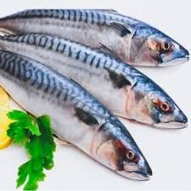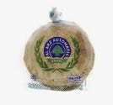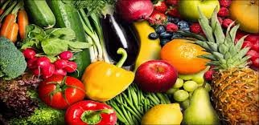

اﻋﺪاد وﺗﻘﺪ�ﻢ: أ / ﺣﻤﺎﻣﻪ اﻟﻤﻨﺼﻮري

ﻣﺮﻛﺰ ﻣﺪﻳﻨﺔ زا�ﺪ