حدد أدوات الطبخ

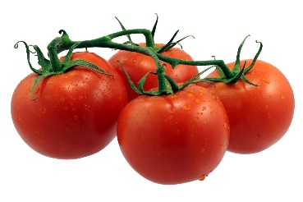



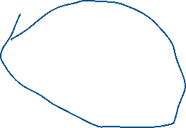

صل بين الكلمه ومرادفها من الصور

جزر



بصل



طماط



خيار