

|  |  |  |  |  |  |  |  |
| --- | --- | --- | --- | --- | --- | --- | --- |
| **اﻻﺧﺘبﺎر اﻟﻴﻮ ي�** | | | | | | | |
|  | **اﻟﺘﺎرﻳﺦ** | **اﻟﻔﺼﻞ اﻟﺜﺎﻟﺚ** | **اﻟﻔﺼﻞ اﻟﺪراﺳﻲ** | **2025** | **اﻟﺴﻨﺔ اﻟﺪراﺳﯿﺔ** | **ﻳٌﻈﮭﺮ ﻣﻌﺮﻓﺔ وﻣﮭﺎرة ﻓﻲ أﺳﺎﺳﯿﺎت اﻟﺰراﻋﺔ واﻹﻧﺘﺎج اﻟﺰراﻋﻲ** | **اﺳﻢ اﻟﻮﺣﺪة** |
| **ﻳﺤﺪد أﻧﻮاع اﻟﺰراﻋﺔ اﻟﺒﺴﯿﻄﺔ واﻟﺒﺪاﺋﯿﺔ واﺣﺘﯿﺎﺟﺎﺗﮭﺎ** | | | | | **ﻣﻌﯿﺎر اﻷداء** | **ﻳﻤﯿﺰ أﻧﻮاع اﻟﺰراﻋﺔ واﺣﺘﯿﺎﺟﺎﺗﮭﺎ** | **ﻣﺨﺮج اﻟﺘﻌﻠﻢ** |
| **اﻟﺪرس 3** | | | | | **رﻗﻢ اﻟﺪرس** | **ﺗﺤﺪﻳﺪ أﻧﻮاع اﻟﺰراﻋﺔ اﻟﺒﺪاﺋﯿﺔ واﺣﺘﯿﺎﺟﺎﺗﮭﺎ** | **اﺳﻢ اﻟﺪرس** |
| 2 | | | | | **اﺳﻢ اﻟﻤﺠﻤﻮﻋﺔ** | ربيع – يوسف -محمد جاسم -محمد سالم | **اﺳﻢ اﻟﻄﺎﻟﺐ/ة** |
| **10** | | | | | | | **درﺟﺔ اﻻﺧﺘﺒﺎر** |
| **.........** | | | | | | | **ﻧﺘﯿﺠﺔ اﻻﺧﺘﺒﺎر** |

**اﺳﺎﻟﺔ اﻻﺧﺘﺒﺎر**

**رﺗﺐ ﺧﻄﻮات )ﻛﯿﻒ ﺗﺰرع ﻧﺒﺘﺔ؟(**

**اﻟﺪرﺟﺎت**

**6**

**5**

**4**

**3**

**2**

**1**

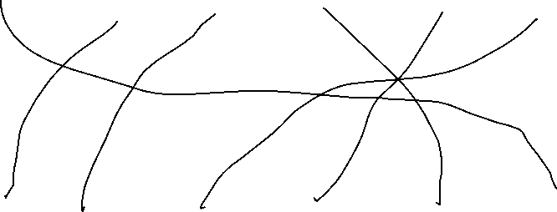

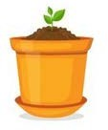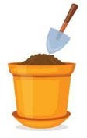

اﻋﺪاد وﺗﻘﺪ�ﻢ: أ / ﺣﻤﺎﻣﻪ اﻟﻤﻨﺼﻮري

ﻣﺮﻛﺰ ﻣﺪﻳﻨﺔ زا�ﺪ