مكان حفظ المواد الغذائيه



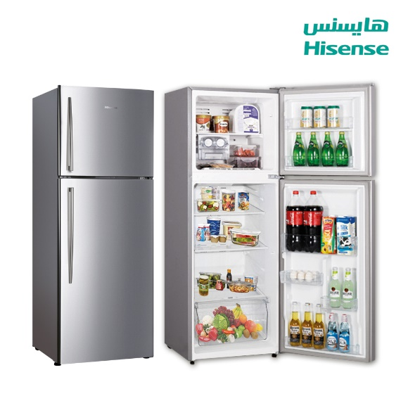

صل بين الكلمه ومرادفها من الصور

بيض

ثلاجة



حليب