قم باختيار صور المحاصيل الزراعية من الصور التالية

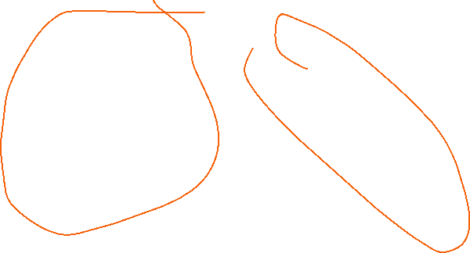

اذكر

صل بين الصورة ومايناسبها

