ضع دائرة على اساسيات الزراعة

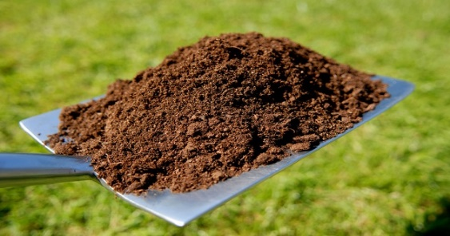

حدد من الصور سقي وزراعة الشتلات الزراعية

اذكر



