حدد من أنواع اللحوم التالية الأسماك

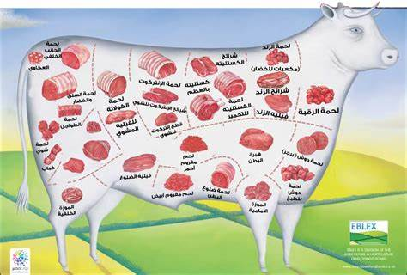

رتب خطوات تجميد الأسماك الصحيحه

2

3

1